Q-3-3

1) Most experts recommend college students get at least 8 hours of sleep per night. A random sample is collected of 112 students at a college by asking how many hours of sleep each student got last night. The sample mean amount of sleep last night was 7.6 hours, with a sample standard deviation of 2.1 hours. The sample distribution of hours of sleep was slightly skewed right.
Use the sample results to estimate the standard error of the sampling distribution of sample means.
a. 2.1
b. 0.198
c. 7.6
d. 0.718

2) Adult male polar bears are expected to weigh, on average, 370 kg. Polar bear's hunt from a platform of sea ice. Scientists are concerned that global warming is melting these platforms earlier in the year, reducing the hunting time and forcing the polar bears inland without the necessary fat reserves to survive summer and fall. The US Geological Survey (USGS) conducted a study in the Southern Beaufort Sea to investigate whether climate change has appeared to negatively impact the weight of polar bears. Eighty-three adult male polar bears were captured between March and May of the years 1990 and 2006 and their weights were recorded. The sample mean weight was 324.6 kg, and the sample standard deviation was 88.3 kg.
A histogram of the 83 polar bear weights in the sample is shown below.
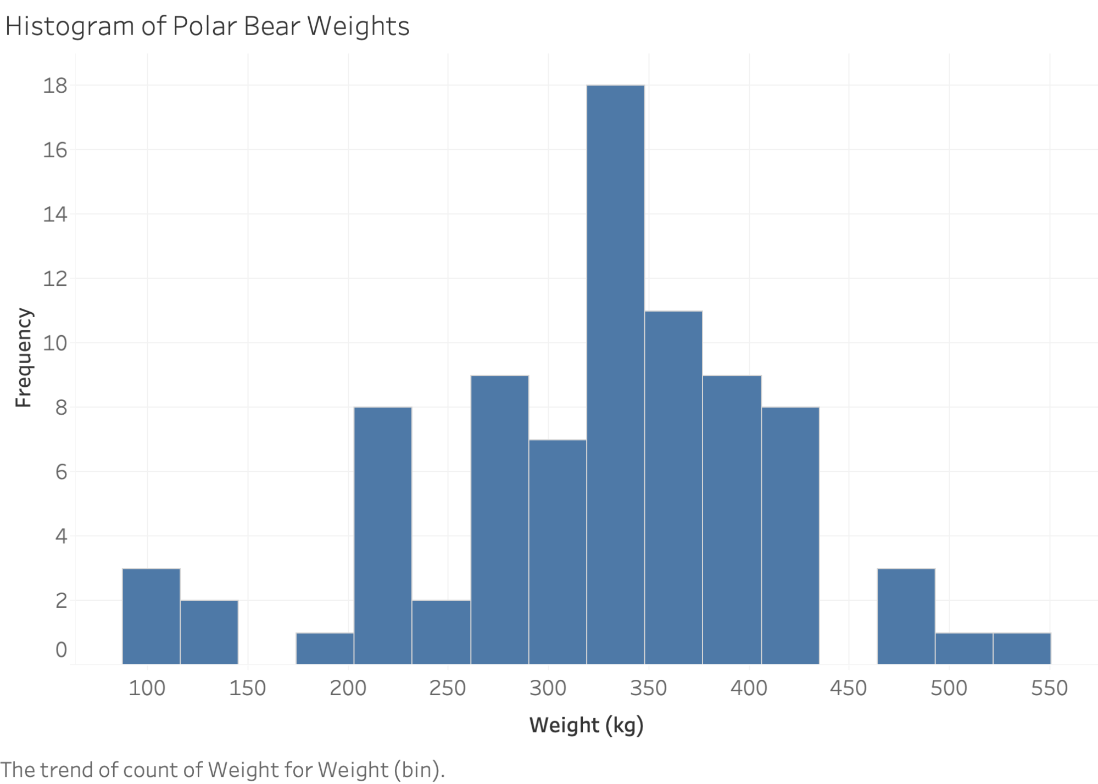
Are the validity conditions for theory-based inference met for these data?
a. Yes, since at least 10 polar bears weighed more than 370 kg and at least 10 weighed less than 370 kg.
b. Yes, since the sample size is larger than 20 and the sample distribution is not strongly skewed.
c. No, since the sample distribution is slightly skewed left.
d. Unable to determine.

3) Adult male polar bears are expected to weigh, on average, 370 kg. Polar bear's hunt from a platform of sea ice. Scientists are concerned that global warming is melting these platforms earlier in the year, reducing the hunting time and forcing the polar bears inland without the necessary fat reserves to survive summer and fall. The US Geological Survey (USGS) conducted a study in the Southern Beaufort Sea to investigate whether climate change has appeared to negatively impact the weight of polar bears. Eighty-three adult male polar bears were captured between March and May of the years 1990 and 2006 and their weights were recorded. The sample mean weight was 324.6 kg, and the sample standard deviation was 88.3 kg.
What are the appropriate null and alternative hypotheses to investigate whether climate change has appeared to negatively impact the weight of polar bears?
a. $H_{0}:\overline{x}$ = 370 versus $H_{A}:\overline{x}$ < 370
b. $H_{0}:\overline{x}$ = 370 versus $H_{A}:\overline{x}$ > 370
c. $H_{0}:μ$ = 370 versus $H_{A}:μ$ < 370
d. $H_{0}:μ$ = 370 versus $H_{A}:μ$ > 370

4) Adult male polar bears are expected to weigh, on average, 370 kg. Polar bear's hunt from a platform of sea ice. Scientists are concerned that global warming is melting these platforms earlier in the year, reducing the hunting time and forcing the polar bears inland without the necessary fat reserves to survive summer and fall. The US Geological Survey (USGS) conducted a study in the Southern Beaufort Sea to investigate whether climate change has appeared to negatively impact the weight of polar bears. Eighty-three adult male polar bears were captured between March and May of the years 1990 and 2006 and their weights were recorded. The sample mean weight was 324.6 kg, and the sample standard deviation was 88.3 kg.
The sample mean of 324.6 kg lies ___(1)____ standard errors ___(2)___ the expected average polar bear weight of 370 kg.
a. 4.68, above
b. 4.68, below
c. 0.51, above
d. 0.51, below

5) Adult male polar bears are expected to weigh, on average, 370 kg. Polar bear's hunt from a platform of sea ice. Scientists are concerned that global warming is melting these platforms earlier in the year, reducing the hunting time and forcing the polar bears inland without the necessary fat reserves to survive summer and fall. The US Geological Survey (USGS) conducted a study in the Southern Beaufort Sea to investigate whether climate change has appeared to negatively impact the weight of polar bears. Eighty-three adult male polar bears were captured between March and May of the years 1990 and 2006 and their weights were recorded. The sample mean weight was 324.6 kg, and the sample standard deviation was 88.3 kg.
A theory-based inference applet gives a p-value less than 0.00001. Do these results provide evidence that the true mean weight of polar bears is less than 370 kg?
a. No, since the sample results could have happened by chance.
b. Yes, since 324.6 kg is less than 370 kg.
c. Yes, since the p-value is small.
d. No, since the p-value is large.

6) If the p-value is very small, which of the following is true?
a. Very strong evidence exists against the null hypothesis.
b. Very strong evidence exists against the alternative hypothesis.
c. The null hypothesis has been proven.
d. The alternative hypothesis has been proven.

